**《Fundamentals of Electric Circuits》homework 3**

**4.14** Apply the superposition principle to find vo in the circuit of Fig. 4.82. (10’)

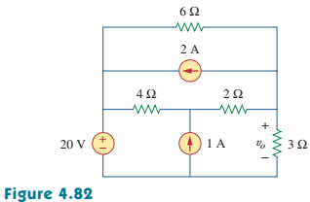

**4.24** Use source transformation to find the voltage Vx in the circuit of Fig. 4.92. (10’)

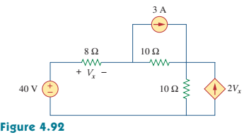

**4.44** For the circuit in Fig. 4.111, obtain the Thevenin equivalent as seen from terminals:

(a) *a*-*b* (b) *b*-*c.* (10’)

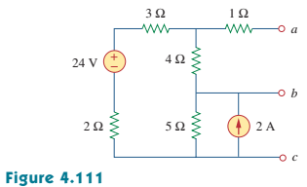

**4.X** Find the Thevenin equivalent at terminals a-b of the circuit in Fig. 4.x.(10’)

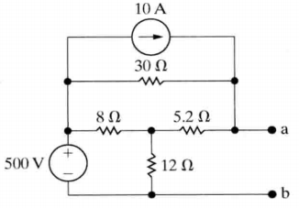

**Figure. 4.x**

**4.48** Determine the Norton equivalent at terminals *a-b* for the circuit in Fig. 4.115.(10’)

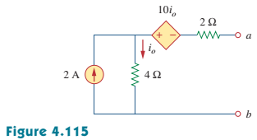

**4.50** Obtain the Norton equivalent of the circuit in Fig. 4.116 to the left of terminals *a-b .*Use the result to find current *i.* (10’)

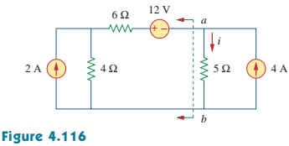

**4.54** Find the Thevenin equivalent between terminals *a-b* of the circuit in Fig. 4.120. (10’)

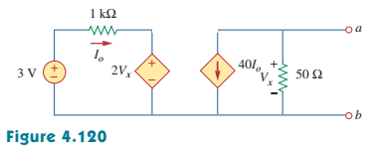

**4.Y** Determine the Norton equivalent at terminals a-b for the circuit in Fig. 4.y

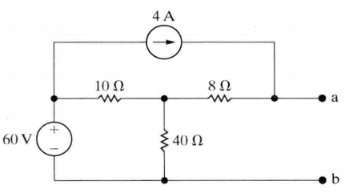

**Figure. 4.y**

**4.72** (a) For the circuit in Fig. 4. 138, obtain the Thevenin equivalent at terminals a-b.

(b) Calculate the current in RL = 8Ω.

(c) Find RL for maximum power deliverable to RL.

(d) Determine that maximum power.

(10’)

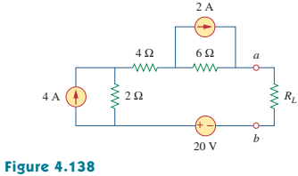

**4.74** For the bridge circuit shown in Fig. 4.140, find the load RL for maximum power transfer and the maximum power absorbed by the load. (10’)

